Deployment of Java Applications on AWS EC2 instances

Using CodePipeline and CodeDeploy

Prerequisites:

Step1: Upload a sample application to your GitHub repository

Step2: Provision EC2 instances

Step3: Create an application and deployment group in CodeDeploy

Step4: Create a pipeline using CodePipeline

1. **Upload application to GitHub repository**

Push application to repository from a specific branch. Files to added to your repository for CodeDeploy and CodePipeline are appspec.yml and other scripts files to install dependencies.

Reference appspec.yml

version: 0.0

os: linux

files:

  - source: /

    destination: /home/ubuntu/

hooks:

  BeforeInstall:

    - location: /install_dependencies.sh

      timeout: 300

      runas: root

    - location: /build.sh

      timeout: 300

      runas: root

    - location: /start.sh

      timeout: 300

      runas: root

1. **Provision EC2 instances**

Launch EC2 instances for your application deployment

* Tag the instance

* Select the AMI image for your instance

* Create a role for EC2 by attaching policy “AmazoneEC2RoleforAWSCodeDeploy” so that CodeDeploy-Agent can access the instance.

* Attach the role to the instance

* Create a security group with inbound rules which opens ports 22 for SSH and 8080 for application.

* Attach key pair login for SSH onto the EC2 instance

* Attach the security group for the instance

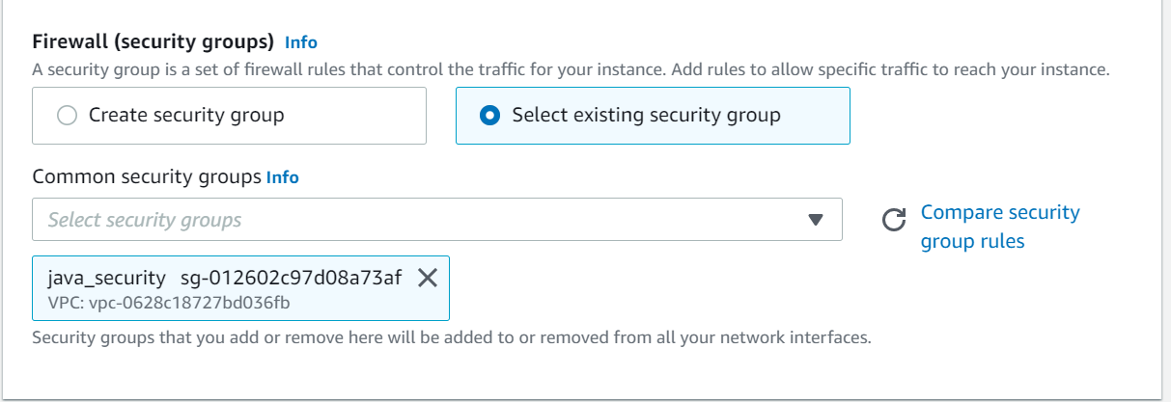

* Add user data as below

Things to modify for above script

Here bucket-name is the name of the Amazon S3 bucket that contains the CodeDeploy Resource Kit files for your region, region-identifier is the identifier of your region

For example: if your region is Asia pacific (Mumbai)

Replace bucket-name with aws-codedeploy-ap-south-2 and region-identifier with ap-south-2.

Finally, your link will be

<https://aws-codedeploy-ap-south-1.s3.ap-south-1.amazonaws.com/latest/install>

1. **Creating deployment and deployment group**

* Create a role for CodeDeploy with Policy attached as AWSCodeDeployRole

* Create deployment application with Compute platform as EC2/on-premises

* Create a deployment group

* Provide Deployment Group name and attach service role created for AWS CodeDeploy

* Choose the Deployment type either **in-place** or **blue/green.**

* Select the Environment Configuration as **Amazon EC2 instances** and add tags of your instances so that CodeDeploy deploys application on the tagged instances.

* Select Agent Configuration so that CodeDeploy will install CodeDeploy-Agent on all instances.

* Configure the deployment by choosing how fast your application is to deploy on instances. Basically, go with Default.DeployAllAtOnce.

* If required assign Load Balancer either Application or Classic Load Balancer.

* Also, can add triggers when a deployment starts or fails.

1. **Creating CodePipeline**

* Create pipeline with role attached or can choose option create role, so that a new role will be created and assigned to the pipeline. Do not forget to tick the below checkbox which permits role creation for CodePipeline.

* choose artifact storage either as default location or AWS S3 bucket.

* Next add source code configuration for our deployment you can choose your source code. connect to your source code through login prompt page and grant authorization access.

* Connect to your source code through login prompt page and grant authorization access.

* Select the repository and branch of your source code
* Choose the GitHub webhooks or AWS CodePipeline to check periodically changes in the repository.

* Next choose build stage or can skip it.

* Next add deployment stage by choosing AWS CodeDeploy, region, Application name and Deployment Group.

* Review the changes and confirm to create pipeline.

Pre-configuration files needed for AWS CodePipeline to run set of sequence commands will be provided in appspec.yml

* Add appspec.yml file to your root location of repository

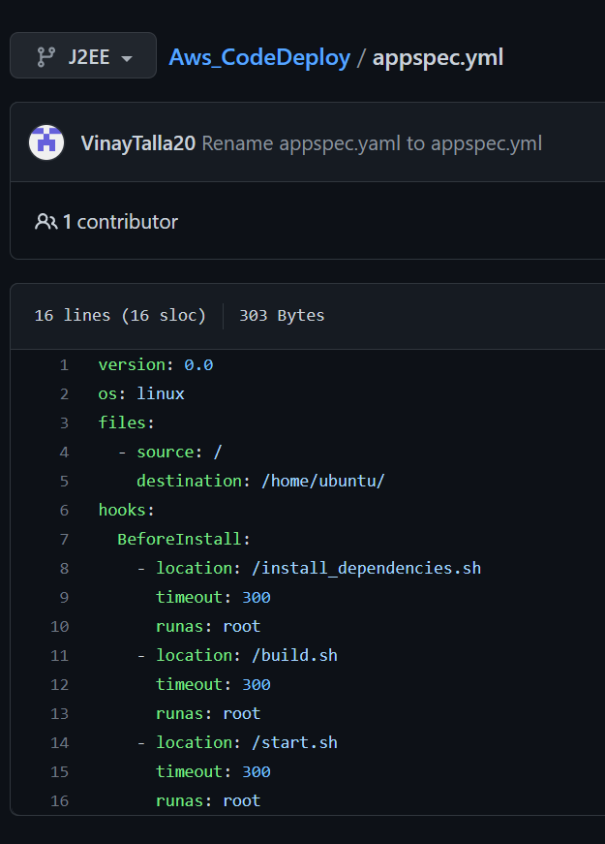

AWS CodePipeline will initiate the hooks as per the sequence

Scripts files for reference

